3D Modelling with 3ds Max – Sprite Bottle

**Table of Contents**

Introduction 2

Creating the Sprite bottle in 3ds Max 3

# Introduction

This is an optional tutorial illustrating different modelling techniques used to model a Sprite bottle in the Web 3D and Mobile 3D Applications module. If you are new to 3D modelling do not attempt this tutorial first as a) it is optional, b) it doe not cover any 3ds Max interface and modelling basics that you need to acquire first.

This tutorial us, however, suitable for gaining extra marks (see the module Rubric) for deeper understanding of the modelling process. You can of course, alternatively, just follow an appropriate online YouTube tutorial to achieve the same outcomes.

# Creating the Sprite bottle in 3ds Max

Completing the 3D coke can in 3ds Max 2022 version has been tested above. The following sections, Sprite Bottle and Dr Pepper Cup have been written for 3ds Max 2019, but as you can see above I have interwoven screen shots from both 3ds Max 2019 and 2022 and there is basically no discernible difference in process so we wont change the text and images below for this season.

Now you have finished the Coke can we will have a go at modelling the Sprite bottle, however, let’s try a different technique this time — you will have seen such techniques in some of the video links in Appendix C, or in previous 3ds Max tutorials. Again, you will need to use a suitable blueprint. Search for a suitable image to use as a blueprint on Google, download and create a sprite_bueprint.jpg, and while you are at it you may as well create your dr_pepper_blueprint.jpg too. I think, if I recall correctly, my Sprite blue print is not 100% symmetrical, so you might find a better one, but having said that, it doesn’t matter that much because this modelling method will produce a symmetrical Sprite bottle.

It is a good idea to use blue prints as reference images to ensure you have the right scale between the three objects you are modelling. You will also need to find suitable textures. However, as before you should feel free to follow/adapt any other online tutorial for creating similar objects if you wish. The objective is to get some 3D modelling experience. As before, for alternative techniques jump to Appendix C.

So, we will now model the Sprite bottle in about 20 key steps:

**Step 1:** Set up an image for reference — you could alternative build the geometry shape by eye, see Figure 56. Don’t forget to push back the blueprint, say 500 in the X direction.

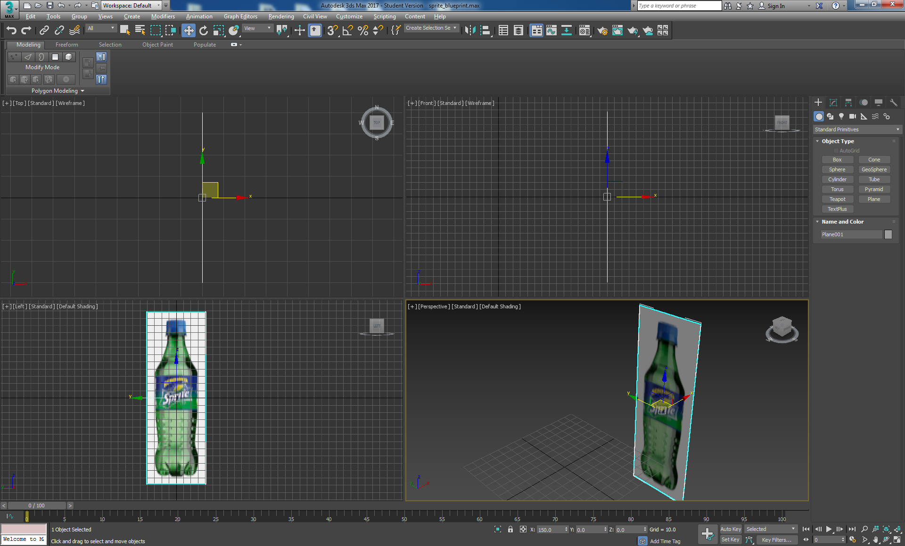

Figure 56: Setup the Sprite blueprint

**Step 2:** Start off with a cylinder primitive (height segments 1, sides 20) positioned 0,0,0. Work in the Left view port, but initially place the cylinder in top view port so that is oriented correctly in the Left viewport, and check the other viewports for accuracy regularly.

We have chosen 20 sides to achieve a reasonably complex geometry to get a better smoothing without being too outrageous on final polygon count — remember, rendering for the web, we need to keep polygon count as low as possible while achieving the desired effect. The reason for choosing 20 sides is that if you look at a physical Sprite bottle and count the dimples and feet they divide into 20 nicely. See Figure 57.

**Step 3:** Move and scale the cylinder to match the Sprite image silhouette, see Figure 57.

**Step 4:** Convert cylinder to editable poly.

**Step 5:** Select and delete the cylinder top cap, see Figure 57. Note here, you can now see inside the cylinder, which appears dark because the surface normal is now opposite to the outside and this is used to determine how you see the render. If you actually render the scene the inside disappears unless you force-2-sided rendering or apply a material to both sides.

|  |  |  |  |  |
| --- | --- | --- | --- | --- |
| Screen Shot 2015-01-05 at 08 |  |  |  |  |
| Step 1 | Step 2 | Step 3 | Step 5 | Step 6 |

Figure 57: Steps 1, 2, 3, 5 and 6 illustrated.

**Step 6:** Select the cylinder and move it down until the bottom edge lines up with the bottom of the label. Scale the bottom to match the silhouette. Select the top ‘Border’, drag up to the top edge of the label and scale again to match the silhouette.

**Step 7:** You can now continue to create segments all the way up to the top of the bottle by selecting the border’, shift and drag up to create a series of segments, each time scaling to match the silhouette, all the way to the top of the Sprite label. Note: you can also use the ‘Extrude’ tool. Continue creating new segments this way all the way to the top of the bottle. You may want to zoom in on various view ports.

**Step 8:** At the bottle top you will need to ‘Extrude’ out, up, in and up to make the rim before modelling the blue top. Figure 58 shows what you should have by now. The top segments are where the bottle top screw thread would go, but we won’t try and model that!

|  |
| --- |
|  |
| Step 8 |

Figure 58: Model the rest of the bottle upper half.

**Step 9:** Continue to model the blue top using the same techniques. You will now need to extrude out a bit, down, out and up again.

**Step 10:** As you get to the top surface of the bottle top start to bevel the top in by make smaller cylinders and scaling in to leave a small hole, then either cap or collapse it, see Figure 59.

|  |  |
| --- | --- |
|  |  |
| Hole needs to be capped or collapsed. | If capping, then select Border, then cap. If collapsing, select edges and collapse. |
| Step 10 | |

Figure 59: Cap or collapse the hole in the bottle top.

**Step 11**: That’s the top half of the bottle modelled, now use either the same techniques to model the bottom half — a combination of shift + move, move, shift+scale, etc. Or alternatively, try the ‘Extrude’ and ‘Bevel’ tools

**Step 12**: Orientate the top half of the model created so far in perspective view, select the polygon, i.e. the bottom cap (make sure ‘Polygon is selected in the ‘Editable Poly’) select the ‘Bevel’ tool (Graphite Modelling Tools), left click and drag up or down to extrude, let go of the left mouse and drag up or down to bevel. Left click again, and repeat to continue creating new bevel cylinders. This is the equivalent of selecting a border, shift move and scaling to follow the shape of the bottle silhouette, except a key difference is that now we are working with polygons rather than edges. See Figure 60. Be careful to make sure only the bottom cap is selected during the bevel operations. You may want to use the Xray, Alt X, mode.

|  |
| --- |
|  |
|  |
| Step 12 |

Figure 60: Start to model the bottom half of the Sprite bottle

**Step 13:** Arrange your viewports to work in the Left viewport and zoom in to continue these bevel operations until you reach the bottom of the bottle following the bottle silhouette as close as possible (note the image I am using as a reference is not exactly orthogonal, but we are only using the reference image as a guide) with the bevel, see **Error! Reference source not found.**.

|  |
| --- |
|  |
| Step 13 |

Figure 61: Using the bevel tool, create segments for the bottom half of the bottle, check your work in each view port.

Figure 62 illustrates the completed segments to the bottom showing the geometry positioned to accommodate the dimples later. At this stage make sure you create as close as possible same height segments for the shape of the areas where the dimples will be created. This is important to get the spacing of the dimples uniform.

|  |  |
| --- | --- |
|  |  |

Figure 62: Segments completed to the bottom of the Sprite bottle, and positions quads to accommodate the dimples

**Step 14:** Continue to use the Bevel to shape up the basic foot geometry on the Sprite bottle, we will return to this later to better shape the feet, see Figure 63.

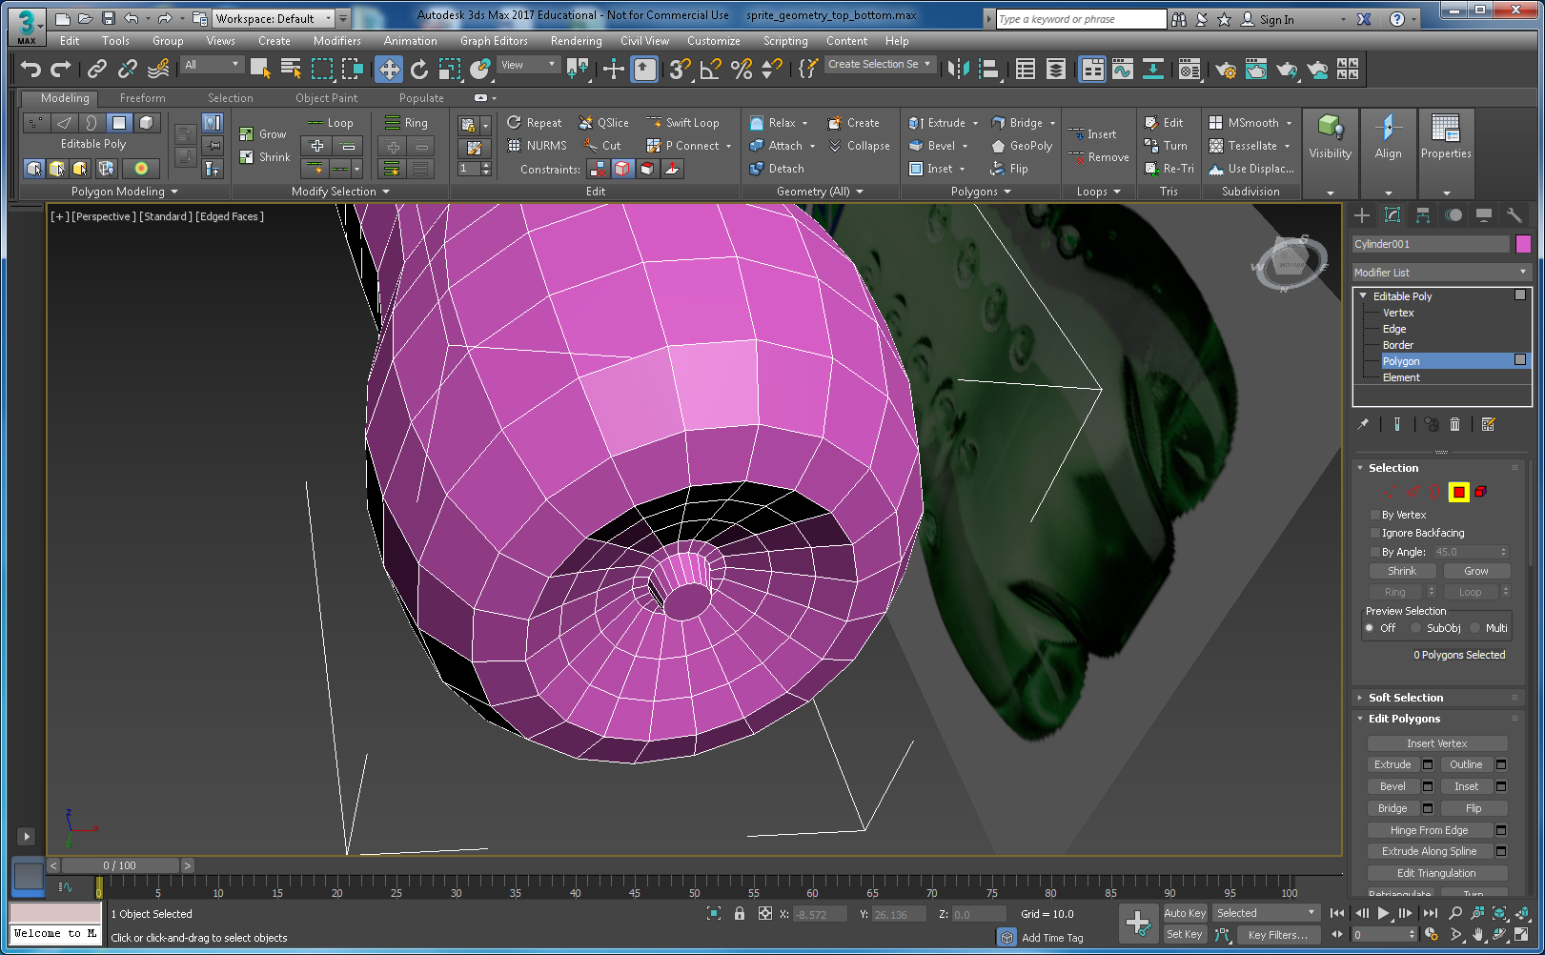

Figure 63: Basic bottom geometry shaped up on the bottom.

**Step 15:** There are now three areas where we can improve the geometry of the Sprite bottle: 1) the feet, 2) the dimples and 3) the thickness/transparency of the bottle. We need to figure out reasonably cost effective (in terms of polygon count) ways to refine the geometry of your model to achieve the best rendering effect for real-time.

Let us work on the dimples first. A cost effective, but crude, way to create the dimples is to use Graphite Modelling Tools such as tessellation, with other operations to create the dimples. Figure 73 illustrates one such. This renders quite well. However, in this part of the tutorial, I don’t write down every single micro-step on how to do the modelling, rather I leave you to explore a bit through trial and error. Consequently, I can never remember exactly how I created the dimples here! Some selection of subdivision and extrude produced the geometry, have a go.

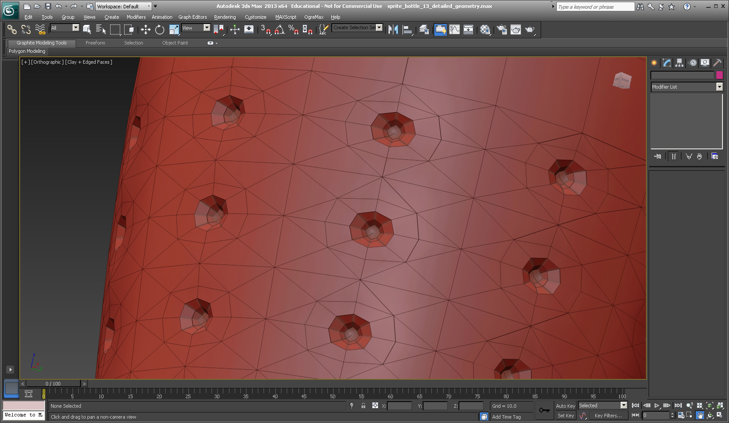

Figure 64: Dimples created by subdividing the polygons and extruding into the bottle

Tip Again! Experimenting with a way to create some simple geometry for the dimples can lead to you needing to do many undo’s. (Ctrl Z). Did you remember to set up the undo level to 200 or more? If not, first, save the current version of your Sprite bottle, e.g. sprite_geometry_dimples.0.1. Then select Customize from the top menu bars, then Preferences and set your undo to 200, or more. Also save often, there is nothing more distressing than having to comfort one of you guys with an unhappy face having lost loads of work. While trying to show loads of sympathy, I will inevitably ask you if you saved regularly, have you checked the Auto backup, and so on.

Anyway, here is one method:

* First, tessellate only the polygons needed to create the dimples with 1 iteration, you will need to select an array of them around the cylinder and down each cylinder — this is where setting the segments to 20 is going to pay off! See Figure 65. Save this selection as dimple-quads, just in case you need to select again more easily. You can do this by typing a name into Named Selection Sets box in the main Toolbar. Once you have the selection saved, you can hide the blueprint because it is getting in the way. You will need to select it, right click and hide selection. Then, reselect the complete bottle, and select polygon in the modify panel, then you can click on the dimple-quad selection to get you selected quads back.
* Next at the position where each dimple will be create select the single vertex, see Figure 66. Again, save the selection, red circle, just in case you accidentally lose it and need to get it back.
* Next select Chamfer and create what is effectively an array of diamond shapes to represent the basic dimple geometry, see Figure 66.

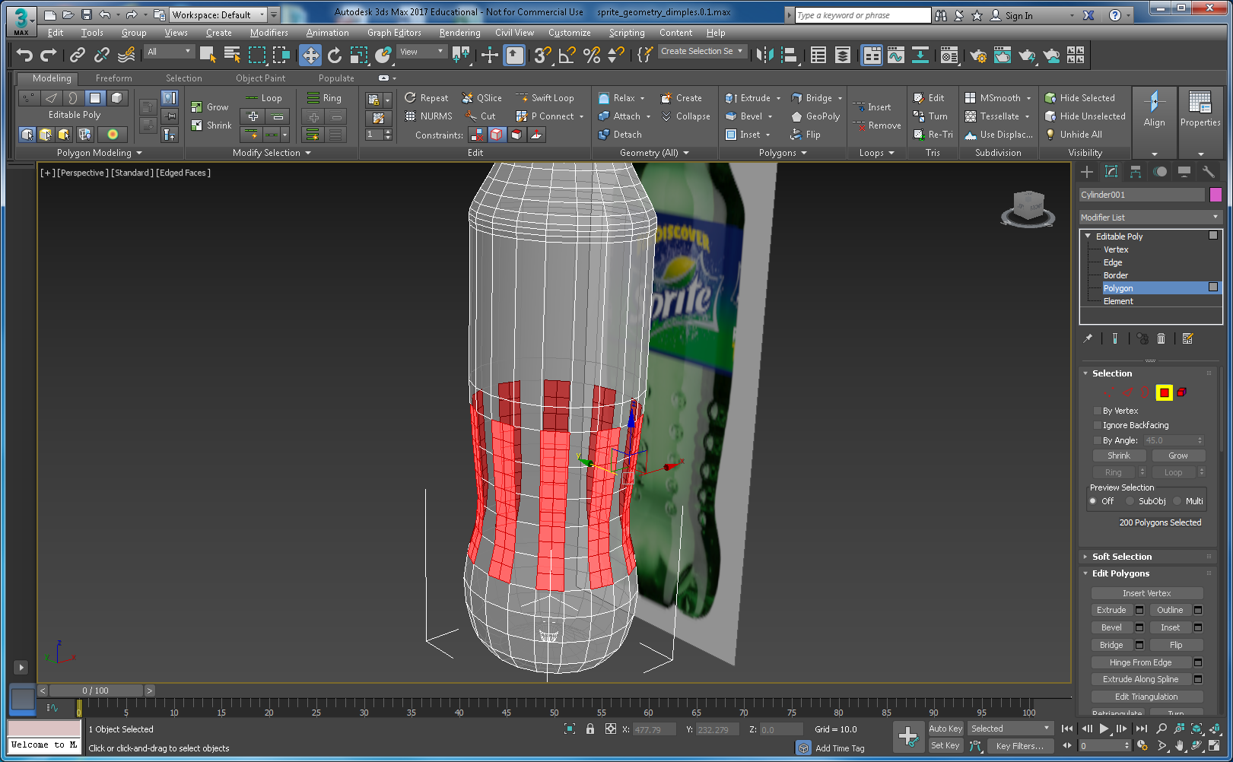

Figure 65: Quads selected and 1 tesselation iteration applied, save the selection.

* Depending on how careful you are with this method (and there are many variations) you may get varying results. This method is a bit trial and error getting the right size of dimple, level of tessellation, and subsequent bevel operations to coax the polygons into a reasonable dimple shape. Nevertheless, it can produce reasonable results, see step 15, Figure 66.

|  |  |
| --- | --- |
|  |  |
| Select the centre vertex | Apply the Chamfer to the vertex |
|  |  |
| Select polygons on the Editable Poly, and shrink if needed to get the centre diamond | Bevel a couple of times |
|  | |
| Nurms and 2 Iterations, and renderd produces a reasonable result, at this stage | |
|  | |
| Smoothing groups applied to the dimples, just to see what the results might look like — could be better! | |
| Step 15 | |

Figure 66: Some simple operations to achieve reasonable dimple geometry.

The last images in Step 15, Figure 66 illustrates the same bottle geometry with NURMS and 2 iterations turned on, and also with smoothing groups applied to the dimples just to see what it might look like. We need to get the dimple geometry similar to the NURMS result.

At this point if you have achieved a decent result like that shown in Step 15, well done. However, you won’t use NURMS, and as you can see smoothing for the dimples could be better. The solution is to:

1. Continue with the Graphite Modelling Tools, e.g. subdivision methods, etc. You can see from Figure 64 that you can get a better geometry, and then apply smoothing groups**. Tip! One iteration of Meshsmooth is ok applied to the bottom of the bottle to include the feet, and smoothing groups applied**, or.
2. Try a different approach, e.g. Boolean some spheres into the bottle to create better geometry. This will take a while.

Feel free to investigate this approach further, but plan your time carefully, you still have the bottle feet to model yet! Let us shape up the feet geometry, and fine-tune the overall geometry. You should also use the Shell Modifier to create an inner shell to simulate the liquid.

**Step 16**: Let us have a go at the bottle feet. Here, I will simple show you a series of images at each stage depicting the way I did it; you may be able to do much better. See Figure 67.

|  |  |
| --- | --- |
|  |  |
| Select the polygons you wish to start manipulating, save as a selection group | Start with a single bevels, judge by eye, then scale it down constrained to face. You can get a feel for what it might look like by clicking on the NURMS. |
|  |  |
| Click on the indicated polygons and constrain to surface, then scale as shown | Select the edges as indicated and scale while constrained to surface, judge by eye. You are trying to widen the feet at the top and narrow them down as you move toward the bottom and go under following the shape of the silhouette curve. Save the edge selection groups, so you can iterate back and forth adjusting the scale of one group of edges compared to the following or previous. |
|  |  |
| Continue to select and scale the next set of edges, repeat all the way down and under the bottle to shape up the feet. You will need to scale the edges inside the foot creases also. You should end up with something like this — [Hidden Line +Edged faces] | If you switch on NURMS, you will get an idea how smooth you can get it. A grat trick here, assuming you have saved your edge selections, is to switch to NUMS, selected the groups of edges and scale in real-time while in NURMS to adjust the feet shape,. |
|  | |
| On the left is a view of rendering with 1 meshsmooth and smooth group applied to the dimples and feet. I applied the smoothing groups. On the right you can see the geometric detail in the Clay rendering. It is interesting to compare Figure 64 with this version. Figure 64 did not use the mesh smooth, if I recall correctly. | |

Figure 67: Shape up the feet

**Step 17**: Make a clone or internal shell of the bottle geometry using the shell modifier, which creates an inner surface facing the opposite direction. You will need to flip the normals on the shell so it faces backwards because you will make the outside surface transparent to a degree, and you will want to see the inside shell surface, which will also be transparent. You might only want to select polygons up to the liquid level to make the shell, then cap it at the top. See Figure 78.

**Step 18**: Break the outer bottle into separate parts to facilitate internal simulation of the liquid — you will need to clone the bottle, select various parts, detach them, etc. see Figure 68.

You might also find it easier to separate the outside polygon section where the texture label goes, to make texturing easier; see Figure 78, which shows the constituent models parts. Rename all parts for easy identification.

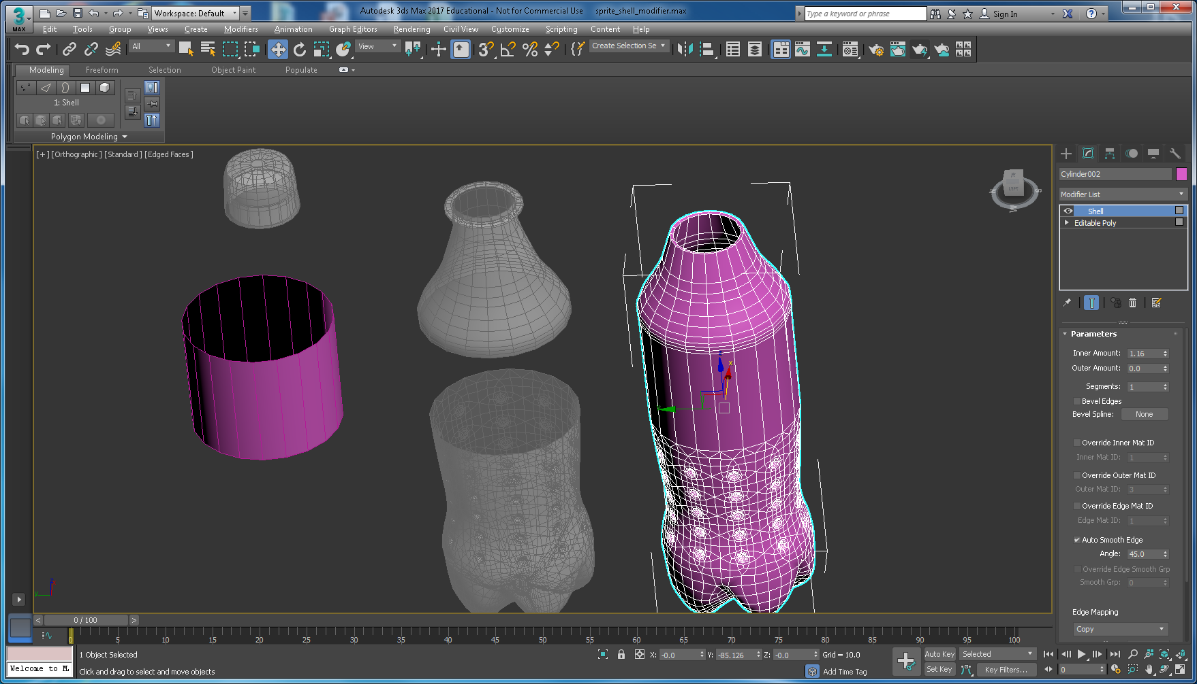

Figure 68: The bottle cloned and chopped up with the Shell Modifier applied to the right hand part to create the inner surface and liquid level.

You will need to collapse the shell and zoom in on the shell’d part to select the outer surface only and delete it. Then cap the inner. You can now apply materials and textures to all the parts and reset their positions to 0.0.0, see Figure 69. You will also need to convert to editable polygon too, as the Shell collapse does not do this. Figure 69 shows the outer shell, the old outer body moved aside and selected ready to delete it; we need the inner body. Don’t forget to cap the inner body, and you will need to Flip Normals on the inner body too.

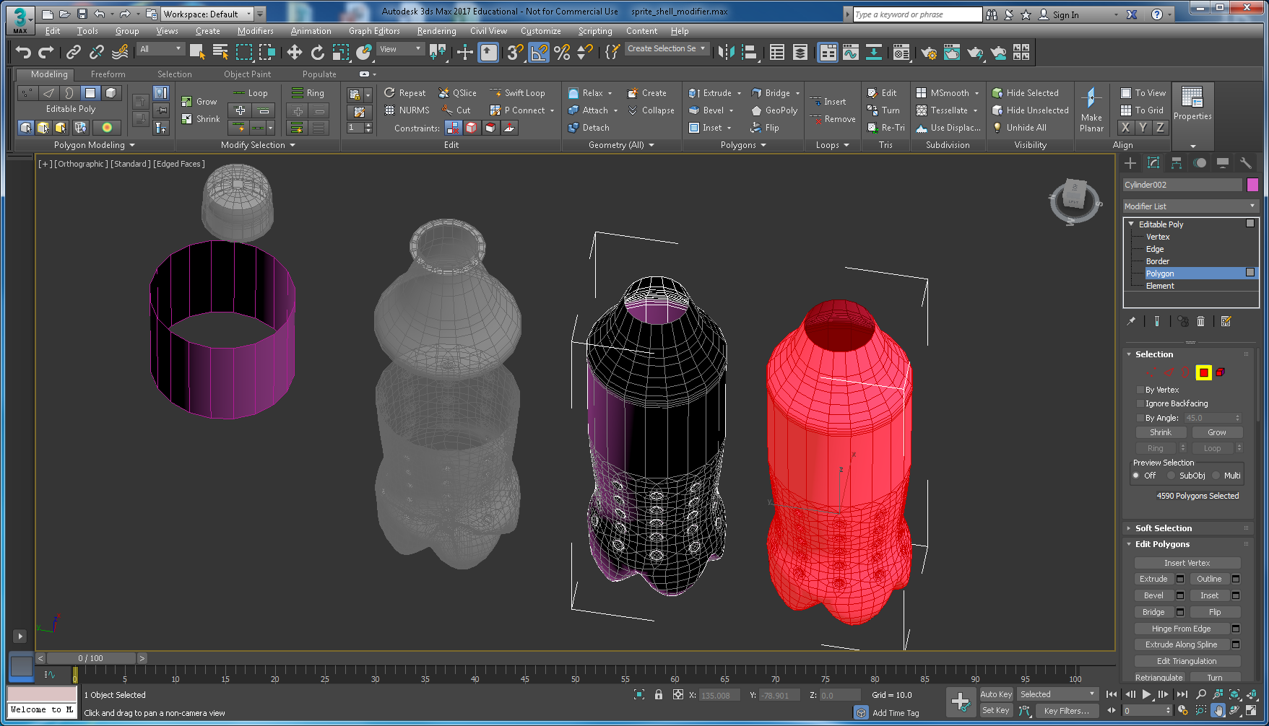

Figure 69: Separate parts of the Sprite bottle

Figure 70 shows the tided-up components ready to apply materials and textures. Inner body on the RHS top capped.

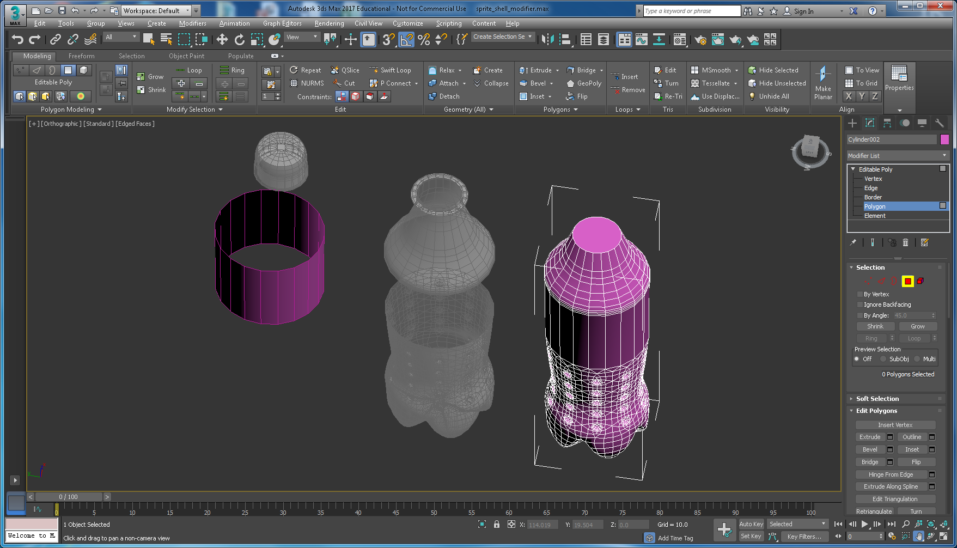

Figure 70: Separate parts of the Sprite bottle ready to apply materials and textures.

**Step 19**: Apply appropriate materials (light green’ish colour and opacity) to simulate the plastic bottle and liquid, and apply the label texture. Don’t forget the bottle top, it’s obviously blue, but you might also want to apply a texture to the top of the bottle top. See Figure 71. This step takes quite a bit of iteration setting the diffuse and specular colours in combination with the opacity in the material editor to get something that looks ok. You need to carefully consider how the opacity (or transparency works) in additive or subtractive mode — search for help on this in 3ds Max. Subtractive works best with light background and additive with dark backgrounds. See Figure 72, which illustrates my first attempt at applying the label texture (as you did the Coke can) and materials to the rest of the bottle.

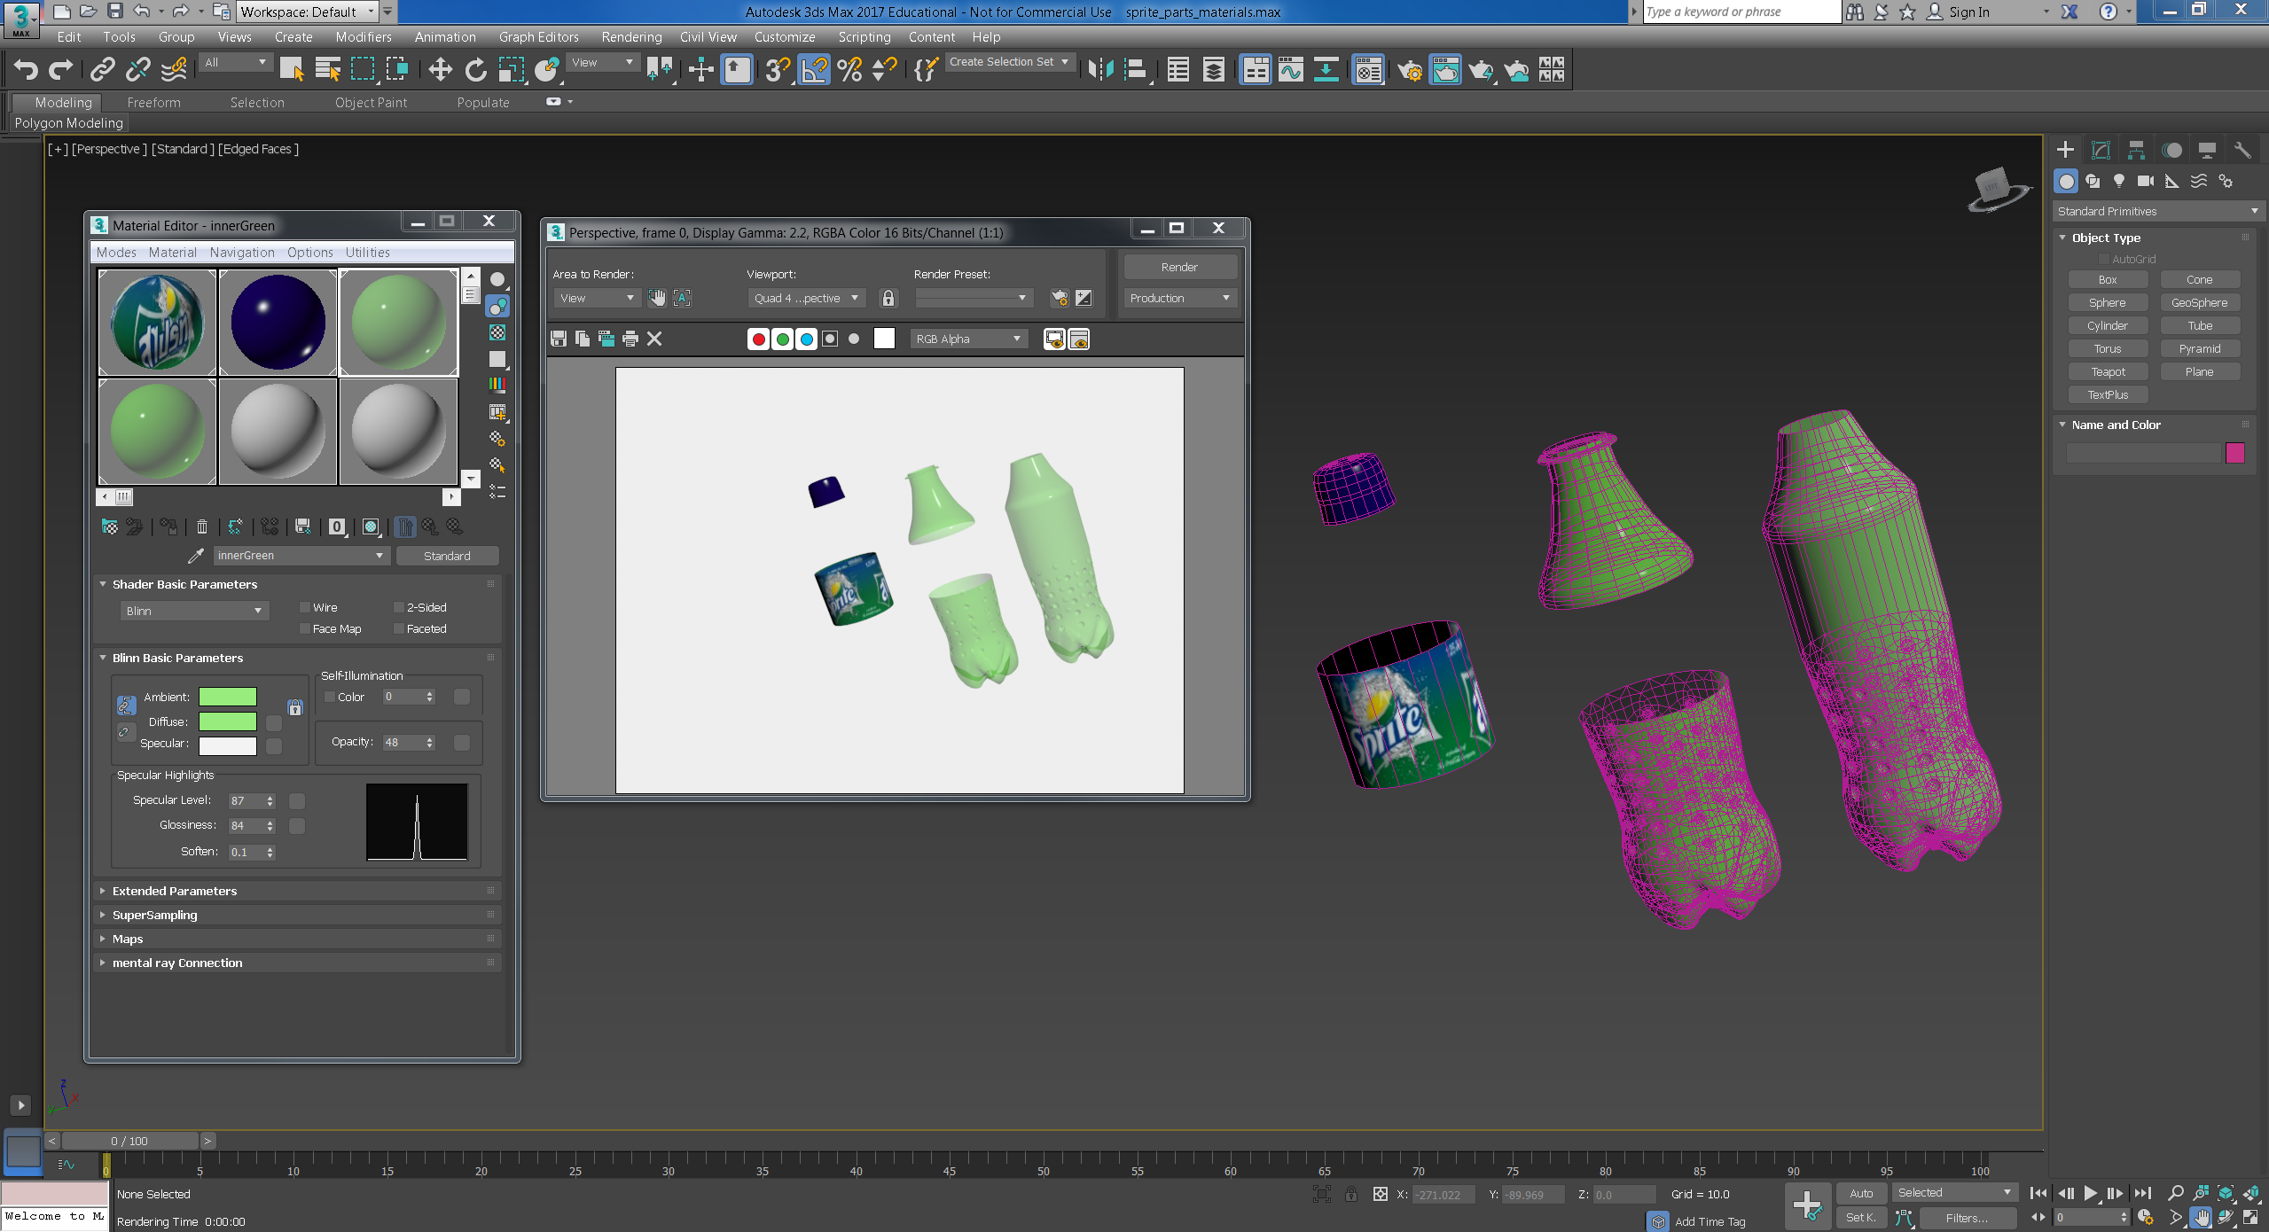

Figure 71: Completed geometry for the Sprite bottle.

**Step 20**: At this point, you could reassemble the Sprite bottle, i.e. reset coordinates for the Sprite bottle constituent parts to 0, 0, 0. Then iterate around adjusting material properties and render to find a good final render. Note, in Figure 71 I set the render background to light grey — go to the Rendered Frame Window and select the Environment and Effects Dialog (Exposure Controls) to change the render background colour. This is important. Later on when in Lab 3 you will export to VRML97 and convert to X3D, your materials properties that govern the render should be chosen with a background colour in mind. So, when you build your assignment models and assign textures and materials you should bare this in mind, i.e. what will be your 3D App background? Also, you can add Background VRML Helper.

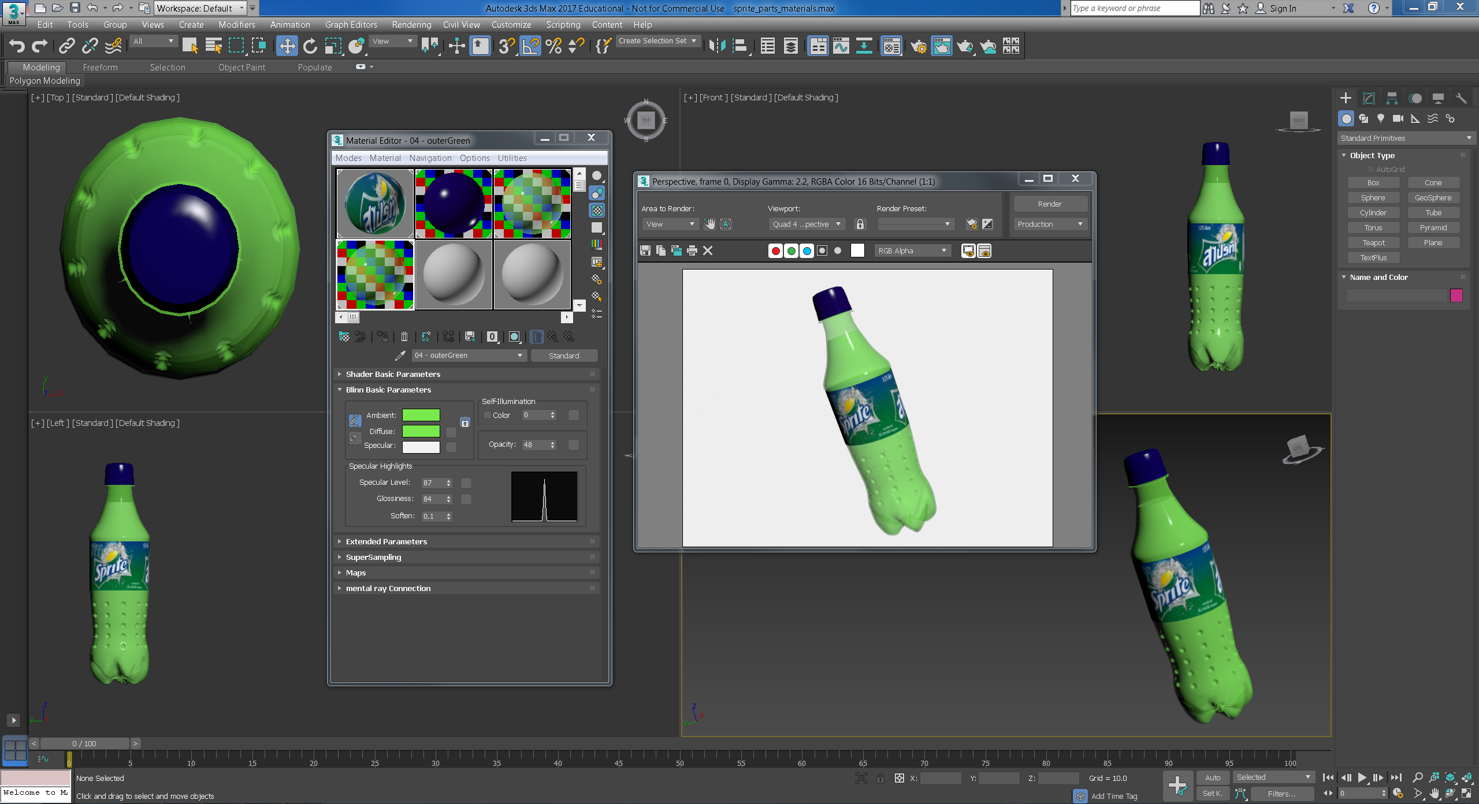

Figure 72: Sprite bottle assembled with materials and textures added

**Step 21**: Do not forget to add appropriate lights and camera viewpoints, then recheck the rendering. I would be surprised if the illumination design does not involve adjusting the materials and, transparency, specular highlights, etc.

To see what the Sprite bottle looks like, export to a Web 3D format (i.e. VRML) see Figure 73. We can see that the materials (Green colour) is a little dark, and I have not really set up lights and cameras properly, so we would go back into 3ds Max and adjust the colours, etc. More on that next week when we look at Web 3D formats.

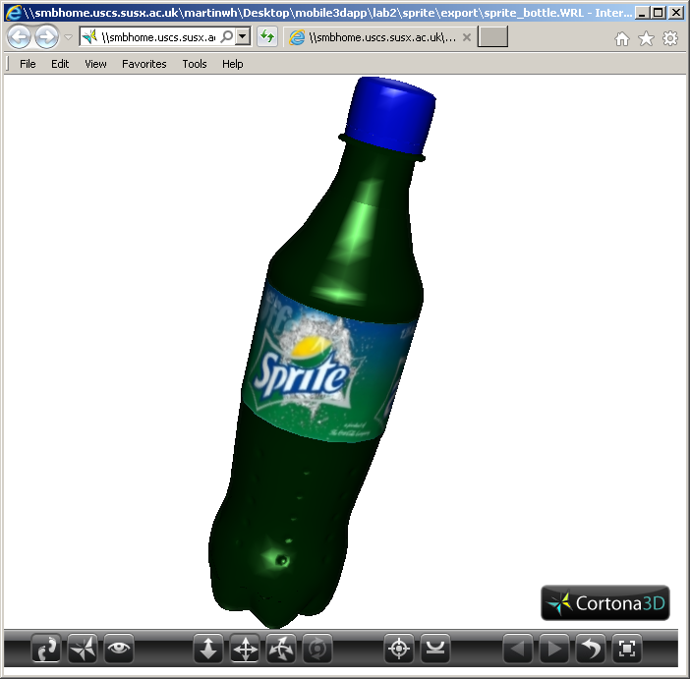

Figure 73: The Sprite bottle exported toVRML and rendered in the Cortona 3D Viewer.